Trauma Informed Teaching
“Trauma is a one time or repeated event that puts a child in the place of feeling left out of control, scared, terrified, worthless, unlovable, insecure, and even endangered”.
Main traumatic events Chris has experienced in his 11 years prior to coming home:
-unmet needs/neglect -poverty -various forms of abuse
-separation from siblings -absence of consistence rules and boundaries
-domestic fighting/violence -poor nutrition
-abandonment by mother -alcoholic father - frequent moves
-abusive foster family -overly medicated -no expectations

As a result, as all children of trauma, Chris has been imprinted with the ideas that he is:
Unlovable Worthless Forgotten or abandoned Powerless
Helpless Hopeless

It is key to understand that because trauma has occurred in the context of relationships, Chris does not inherently trust that the world and adults are safe. Until recently that simply has not been his experience. Repeated experiences that reproduce any of these same feelings have created in Chris a lasting imprint from which he operates and behaves. From what we’ve experienced with Chris is that almost 100% of his fits have roots in his feeling any of these ways in a present situation.
There is always a reason behind behavioral responses, so our first 2 questions are always:
What is driving Chris’ behavior?
How can I make this relationship/interaction safe for Chris (de-escalate)?

Many times we may be tempted to think that Chris just needs to control himself. Many times he can and his growing in this, but there are also many times he cannot. Here is why:
Internal Regulation relates to the child’s ability to regulate themselves both physiologically and psychologically. In a healthy and nurturing environment the baby/child’s caregiver externally regulates the child since the child’s internal system is underequipped. A child, like Chris who has not had the experience of being settled, loved, and nurtured during times of heightened stress, has an internal regulatory system that is not equipped to self-regulate. He has a limited ability to maintain a calm internal presence when the external environment presents challenges and is still learning how to respond or restore himself back to a calm state when stress-inducing events occur.
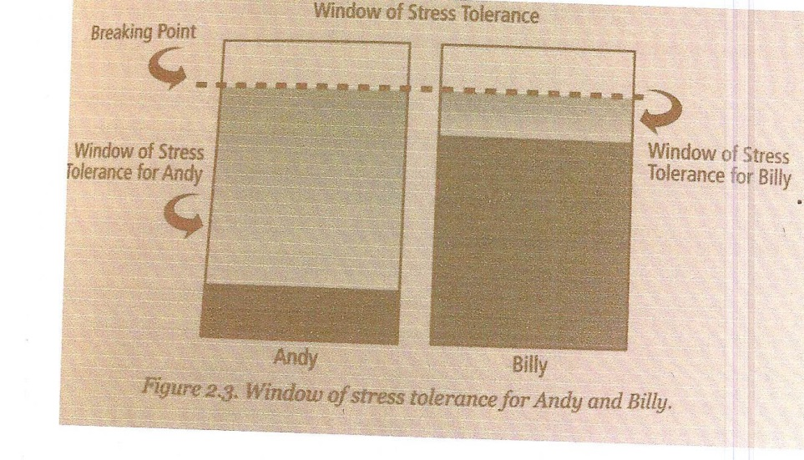

Working within his window of stress tolerance, Chris has the ability to maintain himself in the classroom. In this state, his executive functions are intact and he is able to demonstrate at least beginning levels of:
Self-control Short-term memory Emotional control
Focus Task initiation Planning Organizing
Time Awareness Flexibility Moral Judgment
Logical and sequential thinking Interpersonal skills (the ability to relate)

Chris’ stress tolerance window is a lot smaller than other kids’ however, and he reaches his breaking point faster. Of course school is challenging therefore Chris is working in overdrive to try to keep himself calm and regulated to learn and function appropriately. Frequently, however Chris requires co-regulation from a trusted adult in order for him to move forward. Left to himself Chris has difficulty staying focused, gets behind easily, and then becomes overwhelmed. This leads to him entering a physiological state of survival. If freezing (losing focus) or flighting don’t work and he can’t escape from or deal with the stress with his current coping mechanisms, as we all know, Chris will lash out verbally and/or physically express himself (flight or throwing items).
Obviously we want Chris to learn coping mechanisms to increase his capacity to focus, manage stress, build relationships, and reach his potential. This is for sure a worthy goal. We understand too, however, that Chris is not your average kid and does not always respond to the same typical rewards or consequences for behavior.
The best place for us adults to begin is by developing strategies for increasing:
- A therapeutic teacher-student relationship
- A regulated environment
- Meeting Chris’ emotional needs
- Reducing stress that leads to overwhelm

***The information in the following section reflects these strategies.***
The Connection to the IEP
We are aware that some of these approaches may seem like coddling and attachment therapy mumbo jumbo. We get it. We felt that way too at first. Ten we saw them working. We at first thought we were babying him, but then we saw the strategies accomplish the exact opposite and actually increase Chris’ capacity to manage stress, take responsibility, and learn.
Some typical triggers/antecedents to a Chris “meltdown”
- Being wrong
- Being “out” or losing
- Perception of rejection
- Change of routine (even good fun stuff like an assembly)
- Academic tasks perceived as challenging
- Time constraints
- Feeling behind or stupid
- Frustration
- Anxiety

Interpretations:
Chris’ escalation behaviors (quick dramatic change in demeanor that seems disproportion to the situation, verbal tempo and pitch increase, increased bodily activity, head held down on desk, etc.) to be recognized as a signal of increased anxiety and stress level.
Negative behavior to be recognized as a regulatory issue rather than a behavioral issue (with stress, fear, and overwhelm being the focus) to help student get back on track.
There is always a reason behind behavioral responses, so our first question should be “what is driving Chris’ behavior?”. Secondly, “how can I make this relationship/interaction safe for Chris?”. Seek to understand first.

Relationship:
Chris will be given frequent individual check-ins through his day.
Teachers and staff to provide active listening time to acknowledge Chris’ feelings and to help him build trust in school relationships.

Accommodations:
Chris will be seated in close proximity to the teacher.
Chris is to be reminded that (although a certain activity or assignment may be done as independently as possible or that peers are there to help) he can and should come to the teacher for assistance no matter what.
Chris will have learning activities and projects broken down into smaller manageable chunks with individual due dates on such chunks. This allows Chris to see an end of the assignment.
Chris is made aware of changes in routines in advance notice to allow him to prepare for and process these changes.
Chris is not given consequences for his behavioral issues until he is regulated and calm. Then the consequences are to be discussed. This will allow for him to regain control without further spiraling it out of control.
When discussing behavioral issues, adults will use calm low voices and not stand over him or use a threating stance.

Assistance:
Teacher is to check in with Chris often for correct understanding and organization and to review assignment expectations.
On Fridays, teacher is to record what assignments are missing that week and email to parent and provide to Chris. This allows Chris time to work on them during the weekend at home and attempt to get caught up. Teacher should make sure that Chris has all folders, notes, and books necessary to bring home to complete work.
Student is to be given assistance in setting short-term goals and completing assignments, especially long term assignment such as book reports, projects, and research papers.
Student is to be given assistance with interacting socially when withdrawn.

Behavioral/Regulation:
Chris will be given choices when deregulated: read a book for a few minutes, take a walk with an assigned adult, or go to a safe zone in the classroom until he is able to regroup.
Chris will increase his ability to self-regulate by utilizing strategies for self-calming with visual and/or verbal cues (deep breaths, sucking on a mint, etc.).
Regular repetition of reassurance of safety and that the teacher is in charge to keep her safe all the time and is in charge to keep her safe all the time and is there to help her succeed.
Teacher will help Chris regulate by sitting by student when available, or signaling the student with a prearranged signal such as a thumbs up or thumbs down to monitor mood.
Teacher will use quiet low voice when speaking to Chris.
Teacher will wait until Chris is regulated before speaking about consequences for behavioral problems.
Chris is to be given opportunities to be helpful, such as assigned tasks. This will allow Chris to feel worthy.

Crisis Management:
If it is obvious that Chris needs a break, his frustration level is building, and despite teacher efforts, she refuses to take a recommended break or to accept a calming strategy listed above, the teacher or support person is to get down to Chris’ level and remind him that they are here to help him and want to know the best way that they can do that. Example: “Chris, it seems like you may be (or are) upset right now. I am here to help you. Can you tell me what is bothering you so that I can help?’’ If Chris is still too deregulated to respond, than have him go into a safe room and notify the office. I can be called to help calm him over the phone.

Teachers:
Chris’ team is to be trained about childhood trauma and its effect. Adults are to approach Chris from a calm and collected state of mind as much as possible.
Teachers and staff to avoid power struggles by not insisting that Chris respond verbally in the heat of the moment, but instead allow him time to regulate back down and process with the teacher once calm.
Teacher, principal, or support person to call Chris’ mom if Chris has had repeated increased distress that is having difficulty managing.
Teacher is to include a plan for the student and her substitute packet. This will include a staff member who can support Chris if needed along with simple regulatory based de-escalation techniques for the substitute.

Parents:
Regular emails with parents will be set up to foster positive collaboration and consistent plan from home to school. Parents are to notify teacher of changes in Chris’ life that may lead to deregulation and affect his ability to perform well at school. Parents will be available during the school day (call back within 15 minutes) to check in with student through phone calls as needed for co-regulation or reassurance.
Parents are to provide student at home a routine for homework, checking emails from teachers nightly.
Parents are to be available to assist student at home with homework when student is not deregulated. Parents are to be given the digression to decide if an assignment needs more time or it needs to be done the next day due to Chris’ emotional needs.

Reference: Help for Billy, A beyond consequences approach to helping challenging children in the classroom, Heather T. Forbes, LCSW.

